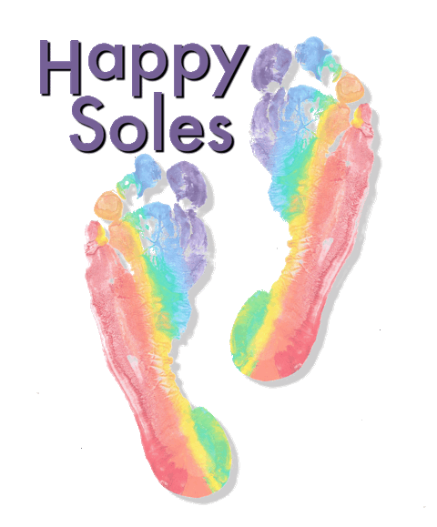
Pregnancy Yoga Registration Form
PERSONAL INFORMATION (PLEASE WRITE CLEARLY)
Name............................................. Date of Birth....................................
Address............................................................................................................
Phone............................. Email:.................................................................... (please write clearly)
YES, please send me a monthly newsletter on email, with updates, offers and news tick here
Emergency contact:…………....................... Phone:............................. Relationship to you................
Occupation........................................Due Date and planned place of birth.......................................
Doctor/midwife practice...................................................................... Phone...................................
HEALTH QUESTIONNAIRE
During pregnancy have you experienced any of the following (please circle any which apply to you)
Aching joints Constipation High blood-pressure Pain from fibroids Anaemia
Depression Pre-Eclampsia Low blood-pressure Lower back pain Anxiety
Diabetes Sciatica Sleep disturbances Morning Sickness Asthma
Dizziness Bleeding Breathlessness Headaches Nosebleeds
Heartburn Oedema Pelvic Girdle Pain Varicose veins Other.......................
Please give details.....................................................................................................................................
Previous pregnancies?.......... Previous miscarriages?....... Previous Births?....... Age(s)......................
Please state any injury or had surgery (e.g. caesarean section, knee surgery) that may affect yoga practice.....................................................................................................................................................
Do you smoke? Y/N Do you drink? Y/N Current medication details.........................................
Have you received any treatments from complementary/ alternative practitioners? Y/N
If so, please give details............................................................................................................................
What do you hope to gain from yoga?.................................... How did you hear about class?...............
CLASS AND PAYMENT DETAILS
Venue: Maxwell Park Community Centre, Maxwell Road, Borehamwood WD6 1JJ
Start date........./......./.........
I enclose cash/ cheque (payable to Caroline Svitana) of £ / I have paid via Paypal £
I agree, for my own safety and wellbeing, to inform the teacher at the beginning of any class, should any changes in the above information occur, or if any medical, physical or emotional problems arise at any time. If you feel unwell always consult your doctor or midwife.
Signed...................................... Printed......................................... Date.........................

